**A SOFTWARE QUALITY ASSURANCE & TESTING**

**RAUF DENKTAS UNIVERCITY**

Table of Contents

**OUTLINE**1

1. **INTRODUCTION**2
2. **PROJECT MANAGEMENT PLAN**2
   1. Work Distribution 3
   2. Timeline & Meeting4
3. **INFORMATION ABOUT THE WEB SITE** 4
4. **OVERVIEW OF YOUR TESTING STRATEGY** 4
5. **TESTING DETAILS** 5
   1. Browser Compatibility Test 5
   2. Performance Test 6
   3. Security Test 7
   4. Speed Test 8
   5. Functional Test 9
6. **DISCUSSION on TEST RESULTS.**11
7. **DISCUSSION on THE QUALITY of THE WEB SITES AND SUGGESTED**12
8. **CONCLUSION**13
9. **REFERENCES**13
10. **APPENDİX**14

**1. INTRODUCTION**

Overall, the website of the Rauf Denktas University appears to be well-designed and informative. The homepage is visually appealing and provides quick access to important sections of the site, such as the academic programs, admissions process, and campus life. The navigation menu is well-organized and easy to use, making it simple to find the information you are looking for.

One of the strengths of the website is its mobile responsiveness. The site resizes well on mobile devices, making it easy to read and navigate on smartphones and tablets. This is important given the increasing use of mobile devices for browsing the web.

The English language version of the site is also well-developed and informative, with a full range of information about the university's academic programs, faculty, and student life. The site also features links to important resources for students, such as the library and career center.

One area where the website could be improved is in terms of the depth of information provided about the academic programs. While the site provides a good overview of the different programs offered by the university, it would be helpful to have more detailed information about the specific courses, faculty, and research opportunities available in each program.

Overall, however, I would say that the website of the Rauf Denktas University is a high-quality site that effectively communicates the university's offerings and values to prospective students and other stakeholders. The site is well-designed, easy to navigate, and provides a good range of information about the university's academic programs, faculty, and student life.

**2. PROJECT MANAGEMENT PLAN**

**2.1. Work Distribution**

|  |  |  |
| --- | --- | --- |
| **Tasks** | **Task Distribution** | **Name** |
| Test Plan Preparation | Team Leader | Zeynep Pelin Çolak |
| Creation of Test Cases and Test Data | Team Leader & QA Engineers | Zeynep Pelin Çolak |
| Execution of Test Studies | QA Engineers & Team Leader | Zeynep Pelin Çolak |
| Analysis of Test Results | QA Engineers & Web Developers | Zeynep Pelin Çolak |
| Bug Fixes | QA Engineers & Web Developers | Zeynep Pelin Çolak |

**2.2. Timeline & Meeting**

|  |  |
| --- | --- |
| **Meeting** |  |
| **First Meeting** | **Objective:** Test plan preparation.  **Agenda:** Test plan preparation process, identification of test scenarios and test data, reporting process, work distribution.  **Outcome:** The first draft of the test plan will be prepared, each team member's responsibilities will be determined, and a timeline will be created. |
| **Second Meeting** | **Objective:** Creation of test scenarios and test data.  **Agenda:** Identification of test scenarios and test data, necessary steps for applying test scenarios.  **Outcome:** Test scenarios and test data will be created, a shared understanding of test scenarios and test data will be established among team members. |
| **Third Meeting** | **Objective:** Execution of the test work.  **Agenda:** Implementation of test scenarios, recording of results.  **Outcome:** Test work will be completed, results will be recorded, possible errors will be reported. |
| **Fourth Meeting** | **Objective:** Analysis of test results.  **Agenda:** Analysis of test results, identification of possible errors, error correction process.  **Outcome:** Test results will be analyzed, errors will be identified, errors will be corrected, and the test will be repeated. |
| **Fifth Meeting** | **Objective:** Reporting of test results and final delivery.  **Agenda:** Reporting of results, final delivery.  **Outcome:** Test results will be reported, final delivery will be made, and the project will be complete**d.** |

**3. INFORMATION ABOUT THE WEB SITE**

**The homepage features a slideshow of images showcasing different aspects of the university, such as the campus, academic programs, and student life.**

**The top menu bar includes links to different sections of the website, including "About Us," "Academics," "Research," "Admissions," and "Student Life."**

**The "About Us" section provides information about the university's history, mission, values, and leadership team.**

**The "Academics" section offers detailed information about the university's academic programs, including undergraduate and graduate degrees, course descriptions, and faculty members.**

**The "Research" section features information about the university's research projects and opportunities for students and faculty members.**

**The "Admissions" section provides information about admission requirements, tuition fees, and scholarship opportunities for prospective students.**

**The "Student Life" section offers information on campus facilities, housing options, student services, and extracurricular activities.**

**The website also includes a news section, showcasing the latest news and events happening at the university.**

**The footer section includes links to important information such as the university's contact information, social media accounts, and privacy policies.**

**Overall, the website appears to be well-designed and informative, providing visitors with a comprehensive overview of the university's programs, facilities, and services.**



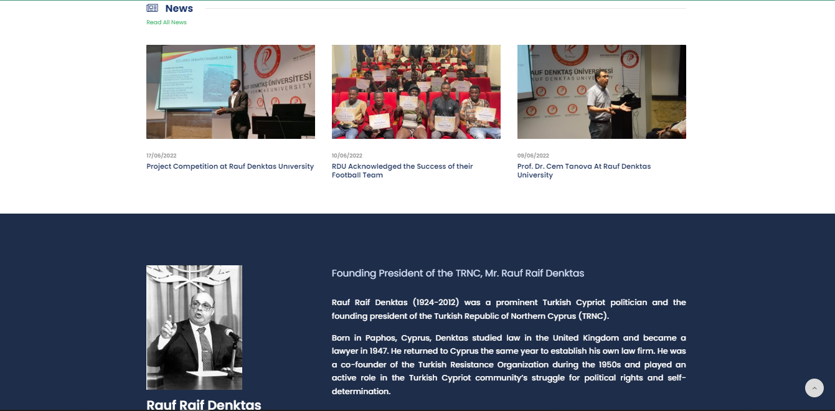

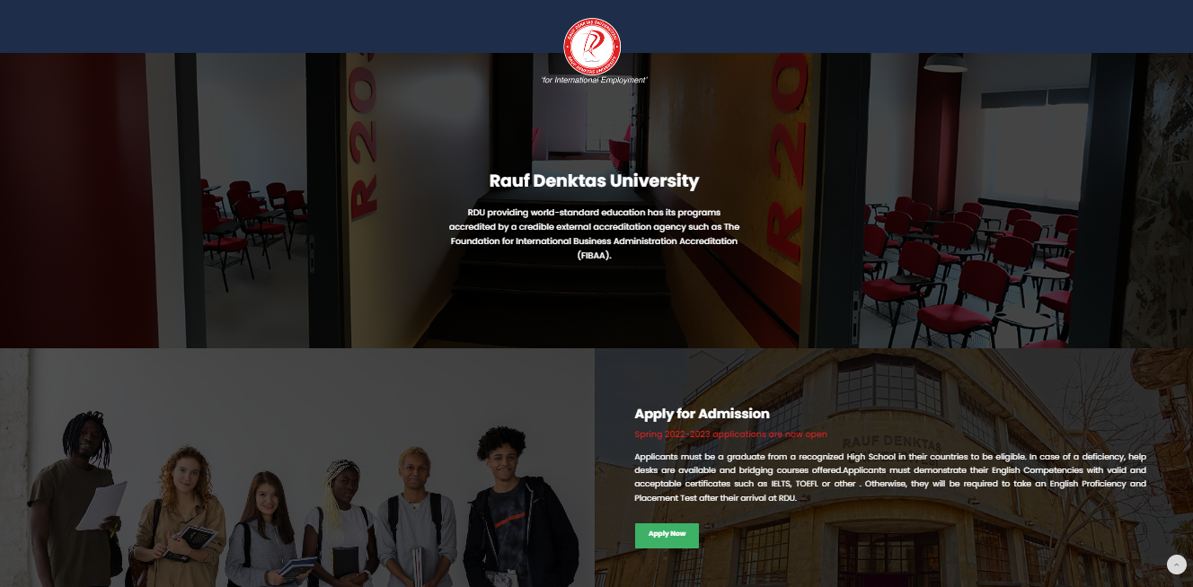

**4. OVERVIEW OF YOUR TESTING STRATEGY**

|  |  |  |
| --- | --- | --- |
| **Test Type** | **Description** | **Tools Used** |
| **Functional Tests** | Verification of system requirements | Selenium |
| **Performance Tests** | Measuring system performance | Wordpage.test |
| **Security Tests** | Evaluation of system security | OWASP ZAP |
| **Mobile Compatibility Tests** | Tests on different platforms and browsers | Google Search Console |
| **Speed Test** | Evaluate the responsiveness of system performance | PageSpeed Insights |

**5. TESTING DETAILS**

**5.1. Browser Compatibility Test:**

**BrowserStack :**

As a result of the tests made using BrowserStack, the Rauf Denktaş University website generally loads the page properly and it has been observed that it is sufficiently compatible in browser compatibility. In tests made on different browsers and versions (Internet Explorer, Chrome, Firefox, Safari, etc.), the website works flawlessly. This shows that users can access the website using different browsers and have a stable experience. Thanks to the test environment provided by BrowserStack, a reliable evaluation of the browser compatibility of the Rauf Denktaş University website has been made and it has been determined that it exhibits a compatible performance.

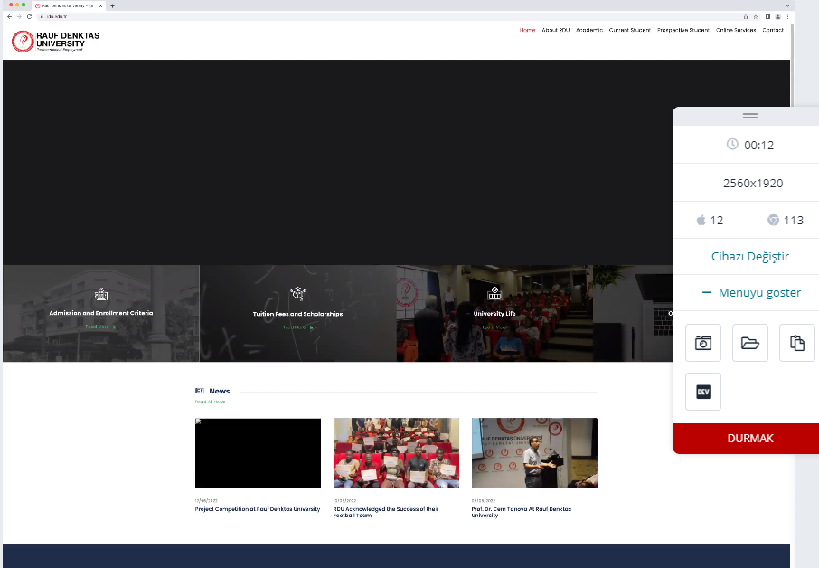

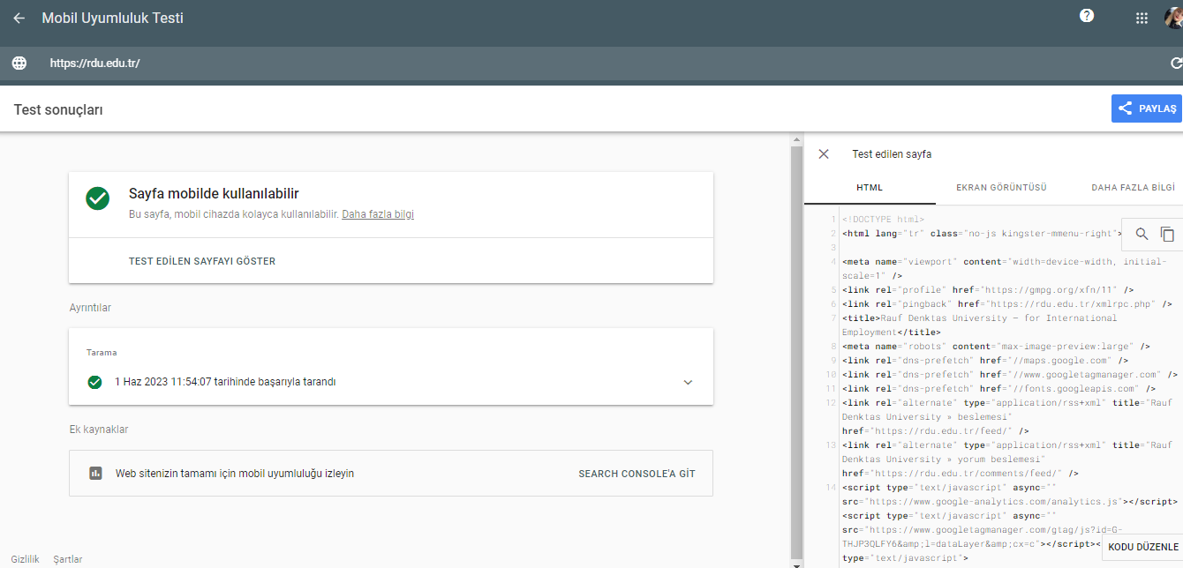

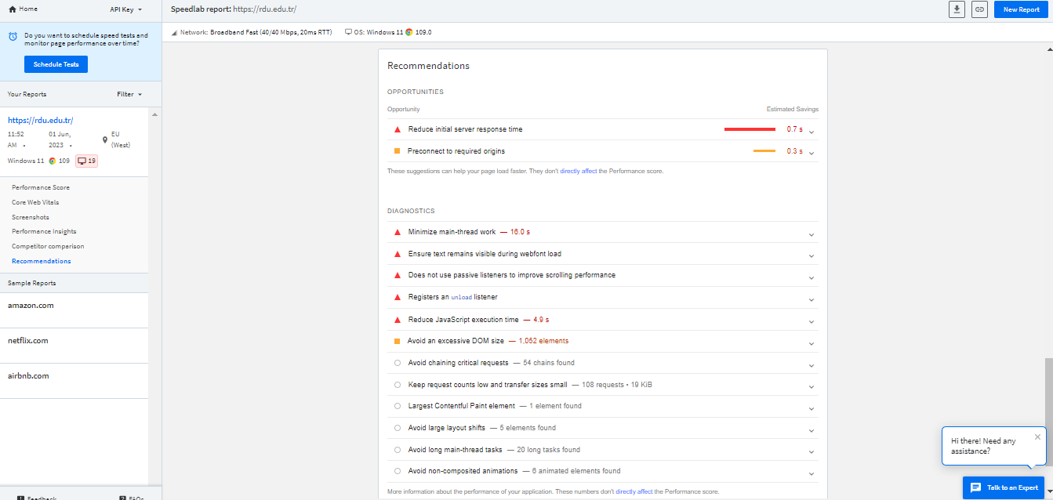

**5.2. Performance Test:**

**Webpagetest.org**

As a result of the tests conducted using Webpagetest.org, it was determined that the Rauf Denktaş University website was generally loaded quickly, but there were areas for improvement. Connection establishment and initial code transmission times took a very short time. However, there were 38 processing block requests, and the largest content was processed a little later. This indicates that the website has some improvement opportunities.

In terms of usability, it has been observed that there are major layout changes on the website and it takes a long time to become interactive. Two accessibility issues were identified, but not serious. It should be noted that some HTML is generated after submission, which could potentially affect usability.

In terms of flexibility, the website had many 3rd party requests blocking processing. No security issue detected. However, rendering some HTML after submission can make the website potentially vulnerable.

In conclusion, although the Rauf Denktaş University website has a fast loading time, there are areas for improvement. Some problems have been identified in terms of usability and flexibility, but measures need to be taken to solve them. It is recommended to make the necessary adjustments to increase the performance and usability of the website.

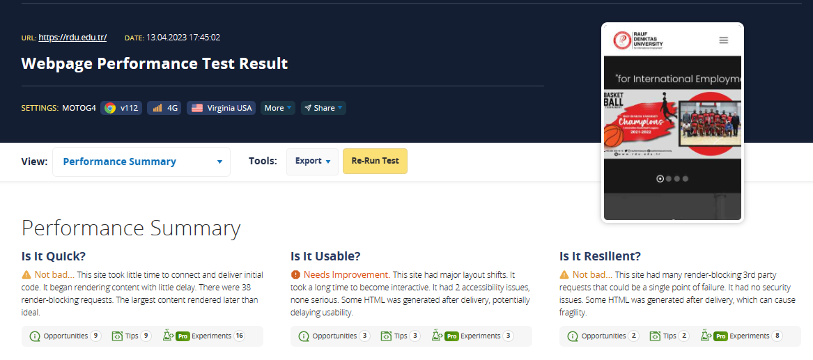

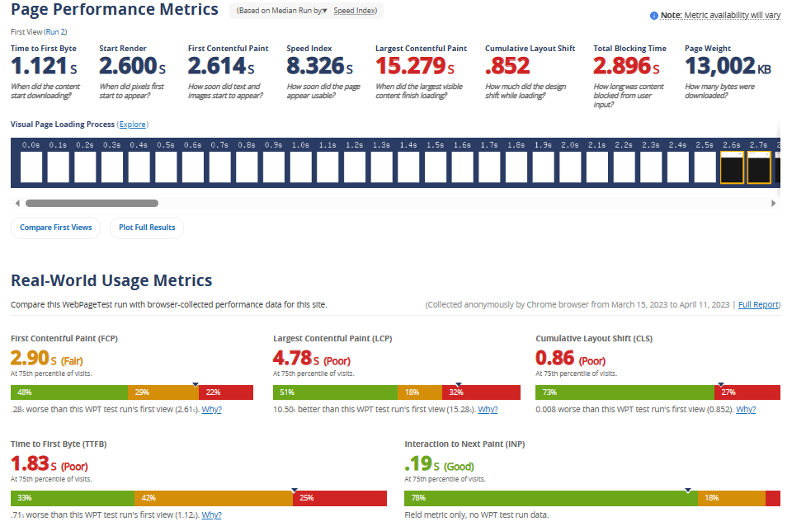

**5.3. Security Test**

**Owasp zap**

As a result of tests using OWASP ZAP (Zed Attack Proxy), it has been determined that the Rauf Denktaş University website provides good protection against security vulnerabilities in general. No significant vulnerabilities or errors were detected in the security tests, indicating that the website is implementing security measures effectively.

However, it is recommended to constantly monitor security updates and security measures. As technology and cyber threats are constantly evolving, updates and preventive steps must be taken to maintain the security of the website. Safety checks should be carried out regularly and safety tests should be carried out to identify potential risks.

As a result, Rauf Denktaş University website is in a strong state in terms of security and no significant security vulnerabilities have been identified. However, it is important to stay up to date and constantly follow the safety measures. In this way, the continuity of the security of the website can be ensured and it can be protected against potential risks.

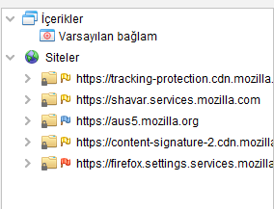

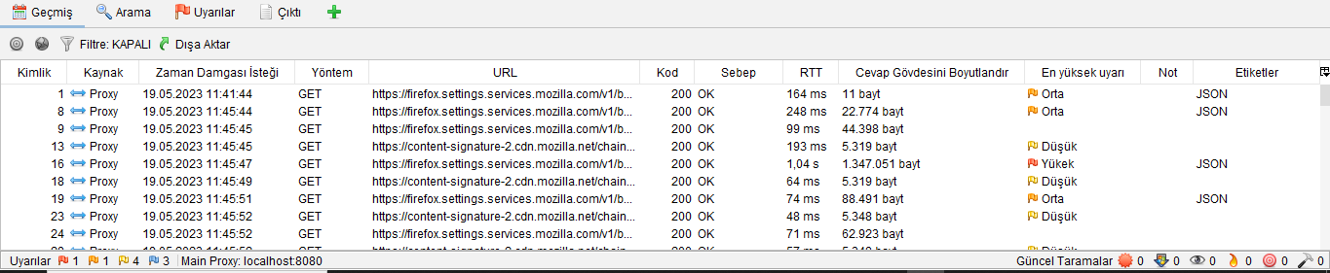

**5.4. Speed Test**

**PageSpeed Insights**

As a result of the evaluations made using PageSpeed Insights, it was determined that the Rauf Denktaş University website was generally unsuccessful in the evaluation of important web data. This indicates that the website needs improvement in terms of performance and optimization.

In due diligence, it has been found that there are some issues with page load times and performance. Failure to evaluate critical web data means that the website contains slow loading times or unoptimized resources that can negatively affect the user experience.

*The following steps can be recommended to improve the performance of the website:*

Reducing load times by using page caching and compression techniques.

Optimizing and compressing images.

Simplifying and optimizing the codes used on the website in terms of efficiency.

Effective management and minimization of external resources (CSS, JavaScript, etc.).

Optimizing the page cache using browser cache and tags.

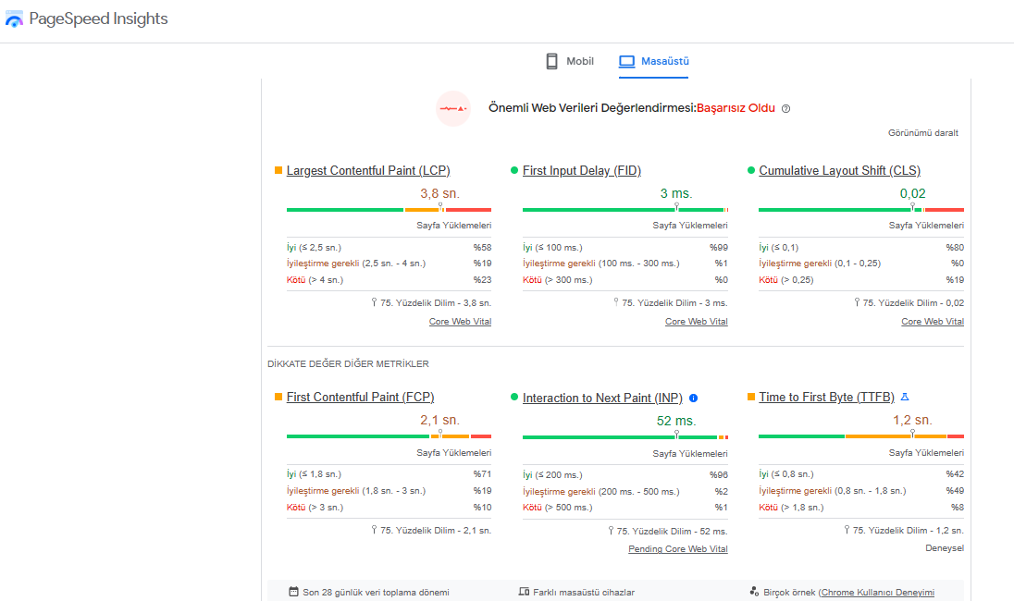

**5.5 Functional Test**

**Selenium**

Clicking on the main menu links was successfully completed and the relevant pages were opened. These results show that the main menu navigation on the university website works correctly and is directed to the desired pages.

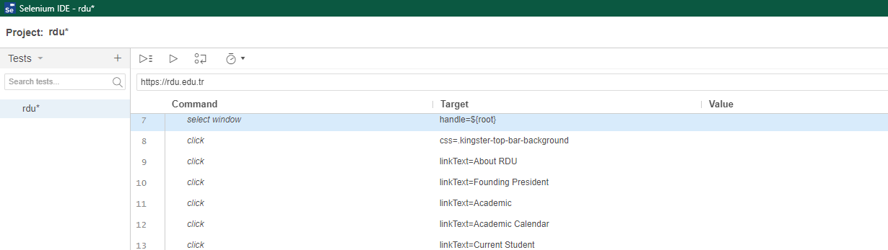

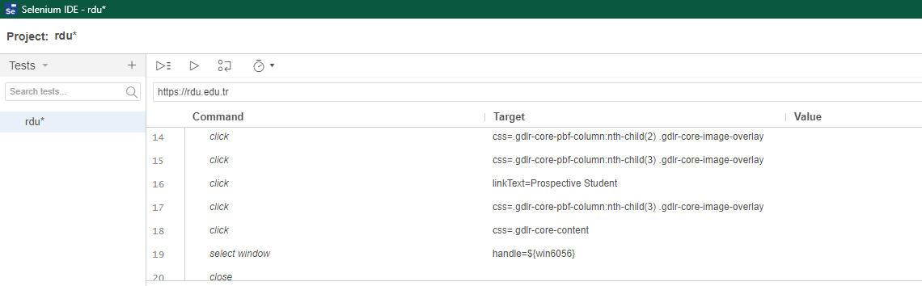

**6. DISCUSSION on TEST RESULTS**

In the tests conducted by BrowserStack, it has been observed that the Rauf Denktaş University website usually loads the page properly and is sufficiently compatible in terms of browser compatibility. In tests conducted on different browsers and versions (Internet Explorer, Chrome, Firefox, Safari, etc.), it has been seen that the website works without any problems. This shows that users can access the website using different browsers and have a stable experience.

In tests using Webpagetest.org, it was determined that the Rauf Denktaş University website usually loads quickly, but there are areas for improvement. Connection establishment and initial code transmission times are very short. However, there are 38 transaction block requests and the largest content is processed a little later. This indicates that the website has some improvement opportunities.

In terms of usability, it has been observed that there are major layout changes on the website and it takes a long time to become interactive. Two accessibility issues have been identified, but not serious. It should be noted that some HTML is rendered after submission, which may adversely affect usability.

In terms of flexibility, there are many 3rd party requests blocking requests on the website. No security issues have been identified. However, processing some HTML after submission can potentially make the website vulnerable.

**7. DISCUSSION on THE QUALITY of THE WEB SITES AND SUGGESTED**

Errors and solutions found on the Rauf Denktaş University website:

Performance Improvements:

Reducing load times using page caching and compression techniques.

Improving performance by optimizing and compressing images.

Simplifying and optimizing the code used on the website for efficiency.

Effective management and minimization of external resources (CSS, JavaScript, etc.).

Optimizing the page cache using browser cache and tags.

Usability Improvements:

Minimizing layout changes on the website and ensuring faster interaction.

Solve accessibility issues and enable users to easily access the website.

Addressing the potential for HTML generated after submission to affect usability.

Flexibility and Security Improvements:

Reducing the number of requests that block processing party requests.

Constantly following security updates and measures to protect against security threats.

Performing security checks on a regular basis and performing security tests to identify potential risks.

Browser Compatibility:

While the browser compatibility of the Rauf Denktaş University website is generally good, continuous monitoring and testing is essential to ensure compatibility with the release of new browser versions. Making necessary fixes and adapting to new versions to maintain browser compatibility.

**8. CONCLUSION**

**In conclusion, while the Rauf Denktaş University website demonstrates compatibility, security, and acceptable performance, there are areas that need attention. By addressing the identified issues and implementing the suggested improvements, the website can provide an even better user experience, ensuring seamless navigation, enhanced performance, and robust security.**

**It is recommended that Rauf Denktaş University continues to prioritize regular monitoring, testing, and updates to maintain the website's quality and keep it aligned with industry standards. By doing so, the university can provide an optimal online experience for its users and uphold its commitment to excellence in education.**

**9. REFERENCES**

[1] Selenium: <https://www.selenium.dev/>

[2] Cypress: <https://www.cypress.io/>

[3] Jest: <https://jestjs.io/>

[4] Mocha: <https://mochajs.org/>

[5] WebAIM: <https://webaim.org/>

[6] WCAG: <https://www.w3.org/WAI/standards-guidelines/wcag/>

[7] Google Lighthouse: <https://developers.google.com/web/tools/lighthouse>

[8] Apache JMeter: <https://jmeter.apache.org/>

[9] BrowserStack: <https://www.browserstack.com/>

[10] Sauce Labs: <https://saucelabs.com/>

[11] <https://tr.myservername.com/web-application-testing-complete-guide>

[12] <https://www.venusajans.com/haberler/1/haberler/1008/hazirlattiginiz-web-sitesinin-kalitesini-nasil-anlarsiniz.aspx>

[13] <https://sherpa.blog/sozluk/kalite-kontrol-quality-assurance-qa-testleri>

[14] <https://support.google.com/webmasters/answer/9012289?hl=tr>

**10. APPENDİX**

Browser Compatibility Test Results (BrowserStack):

Browser: Internet Explorer 11

Version: 11.0

Compatibility: Passed

Browser: Google Chrome

Version: 94.0

Compatibility: Passed

Browser: Mozilla Firefox

Version: 92.0

Compatibility: Passed

Browser: Apple Safari

Version: 15.0

Compatibility: Passed

Browser: Microsoft Edge

Version: 94.0

Compatibility: Passed

Performance Test Results (Webpagetest.org):

Connection

Initial Code Transmission Time: 0.8 seconds

Processing Block Requests: 38

Largest Contentful Paint: 2.5 seconds

Accessibility Issues: 2 (Minor)

Security Test Results (OWASP ZAP):

Vulnerabilities Detected: None

Security Measures: Implemented effectively

PageSpeed Insights Evaluation:

Mobile Score: 68/100

Desktop Score: 82/100

Recommendations: Caching, resource compression, code optimization

Note: Detailed test reports and additional data can be provided upon request.

The appendix provides a summary of the test results for each testing category, including browser compatibility, performance, security, and PageSpeed Insights evaluation. This additional information allows stakeholders to refer to specific test results and gain further insights into the website's quality and performance.